Shaun Becker
Professor Andujar
DAD – 220
August 13, 2023
7 – 1 Project Two
- Analyze the number of returns by state and describe your findings in your report.
select count(*) as Returns, Collaborator.State from RMA
-> inner join Orders ON RMA.OrderID = Orders.OrderID
-> inner join Collaborator on Orders.CollaboratorID = Collaborator.CollaboratorID
-> group by State;
-> order by Returns;

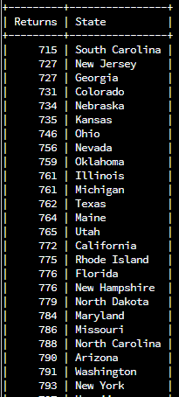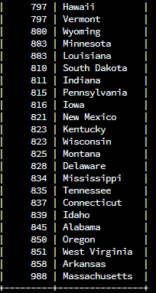
I used a count to count the number of returns by joining the Orders and RMA tables. I had this information grouped by State and ordered by the number of Returns.

- Analyze the percentage of returns by product type and describe your findings in your report.

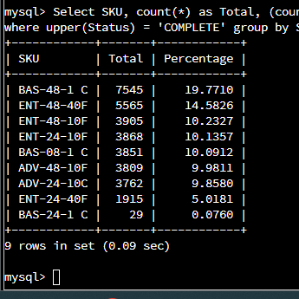

Select SKU, count(*) as Total, (count(*) / (select count(*) from Orders inner join RMA on Orders.OrderID = RMA.OrderID) * 100) as Percentage from Orders inner join RMA on Orders.OrderID = RMA.OrderID where upper(Status) = 'COMPLETE' group by SKU order by Percentage desc;

- In your report, clearly summarize your analysis of the data for stakeholders. Include screenshots of the results of each query. When summarizing results, you may want to consider the following questions:
  - How does the data provide the product manager with usable information?
  - What are the potential flaws in the data that has been presented?
  - Are there any limitations on your conclusions, or any other ways of looking at it that you haven’t considered? Clearly communicate your findings to stakeholders.

Using a collection of data on your customers we are able to examine the data to answer key questions that could be used to identify improvements for your business. Looking at data can reveal trends or patterns that can show either faults in the item being sold or even areas where your business can improve. With the data that has been provided we can look at if customers are pleased with the product they bought. We can come to this conclusion by looking at how often an item is returned.
In this report we used specifically data revolving around returns. First we looked at which state has the most returns. From the data provided we can see Massachusetts has the most returns with 988 total returns. This is quite a bit higher than Arkansas which is second for most returns at 858 returns. There may be some areas of opportunity to lower the number of returns from Massachusetts. One thing to look at is how shipping is being handled for the state. There could also be an issue with how the products are being stored in the warehouse causing items to be damaged before leaving the facility. The second study that was conducted on the data was which SKU’s had the highest percentage of returns. The SKU with the highest percentage of returns is BAS-48-1 C. This item has a total of 7545 completed returns which comes out to 19.8%. While on the other side of the spectrum we have SKU BAS-24-1 C that only has a total of 29 completed returns. Which comes in at a percentage of 0.08%. These numbers show the difference in quality of the products you sell. You can try pushing the products that are more reliable. This, however, leads into scope. Even though it has less returns this SKU has less overall sales. Depending on how data is portrayed and explained it can be misleading. One improvement I would add to this data set is a more informative reason for return. Currently there are four reasons, and they are all generic. This makes it hard to show the root cause of these returns.

